|  |  |
| --- | --- |
| **Project Case** |  |
| GAME6043  3D Modeling for Games |
| **Computer Science** | **O202-GAME6043-RM01-00** |
| ***Valid on*** *Odd Semester Year 2019/2020* | **Revision 00** |

1. Seluruh kelompok tidak diperkenankan untuk:

*The whole group is not allowed to:*

* + - Melihat sebagian atau seluruh proyek kelompok lain,

*Seeing a part or the whole project from other groups*

* + - Menyadur sebagian maupun seluruh proyek dari buku,

*Adapted a part or the whole project from the book*

* + - Mendownload sebagian maupun seluruh proyek dari internet,

*Downloading a part or the whole project from the internet,*

* + - Mengerjakan soal yang tidak sesuai dengan tema yang ada di soal proyek,

*Working with another theme which is not in accordance with the existing theme in the matter of the project,*

* + - Melakukan tindakan kecurangan lainnya,

*Committing other dishonest actions,*

* + - Secara sengaja maupun tidak sengaja melakukan segala tindakan kelalaian yang menyebabkan hasil karyanya berhasil dicontek oleh orang lain / kelompok lain.

*Accidentally or intentionally conduct any failure action that cause the results of the project was copied by someone else / other groups.*

1. Jika kelompok terbukti melakukan tindakan seperti yang dijelaskan butir 1 di atas, maka **nilai kelompok** yang melakukan kecurangan (menyontek maupun dicontek) akan di – **NOL** – kan.

*If the group is proved to the actions described in point 1 above, the score of the group which committed dishonest acts (cheating or being cheated) will be “Zero”*

1. Perhatikan jadwal pengumpulan proyek, segala jenis pengumpulan proyek di luar jadwal tidak dilayani.

*Pay attention to the submission schedule for the project, all kinds of submission outside the project schedule will not be accepted*

1. Jangan lupa untuk melihat kriteria penilaian proyek yang ditempel di papan pengumuman, atau tanya asisten anda.

*Don’t forget to look at the project assessment criteria that posted on the announcement board, or ask your teaching assistant.*

1. Persentase penilaiaan untuk matakuliah ini adalah sebagai berikut:

*Marking percentage for this subject is described as follows:*

|  |  |  |
| --- | --- | --- |
| **Tugas Mandiri**  *Assignment* | **Proyek**  *Project* | **UAP**  *Final Exam* |
| 40% | 60% | - |

1. Software yang digunakan pada matakuliah ini adalah sebagai berikut:

*Software will be used in this subject are described as follows:*

|  |
| --- |
| **Software**  *Software* |
| 3D Studio Max 2019 |

1. Ekstensi file yang harus disertakan dalam pengumpulan tugas mandiri dan proyek untuk matakuliah ini adalah sebagai berikut:

*File extensions should be included in assignment and project collection for this subject are described as follows:*

|  |  |
| --- | --- |
| **Tugas Mandiri**  *Assignment* | **Proyek**  *Project* |
| MAX, Image Files (JPG / PNG) | MAX, Image Files (JPG / PNG), Video Files (AVI / MP4) |

## Soal

*Case*

**Final Fantasy**

Your task is to create a 3D modelling object that realistic and resembles its original form. Choose one of the characters in the **Final Fantasy** game that have a humanoid model.

Detail of humanoid model rules:

* Must have minimum 1 head
* Must have minimum 2 hands
* Must have minimum 2 legs
* Must have minimum 3 hand links
* Must have minimum 3 leg links
  + - 1. **Choose Your Character**

Your character must be unique and different with the other student. Find the image of character’s appearance from different angle. A good Character’s appearance image will provide detailed view from the character’s **front**, **side**, **back**, and **top** (**optional**).

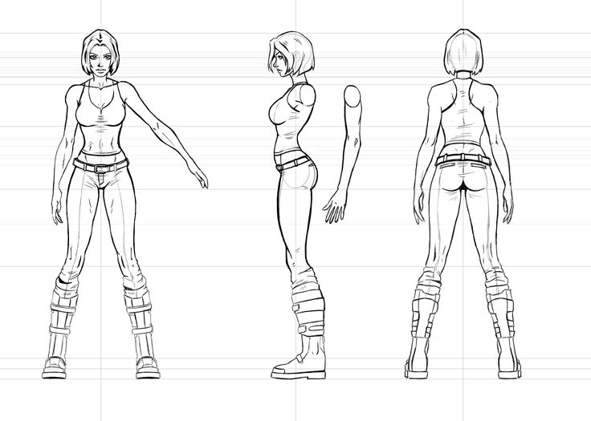

**Image 1 Character’s appearance image example [1]**

Submit your characters idea and character’s appearance image that you choose to your assistant. Maximum submission process can be done on the 4th practicum session. Your assistant will validate the availability and acceptability of character that you choose.

If Student has not submitted the idea of the character, in case, there is similarity with the other character, then the character that has not submitted will not be marked.

* + - 1. **Modeling Your Character**

Modelling your character based on the character’s appearance image that already submitted. With higher polygon count, it will be harder to render your character during rendering process, so it’s preferable to keep your polygon count optimized.

* + - 1. **Modeling Accessories**

You need at least **two** accessories. E.g.: weapon, watch, belt, mask, and so on. The accessories must match the character based on the real one. If the real one doesn’t have any accessories, you can create other accessories, but still must match the character.

Your character must wear the accessories on their body. The character’s original clothing is not counted as an accessory (if you create your own clothing for your character, it will be counted as an accessory).

* + - 1. **Texturing**

The next step is to color your character with texture. You can **search online** for texture or **create your own texture**. Use high-resolution texture and texture mapping/unwrapping technique to obtain a good texture.

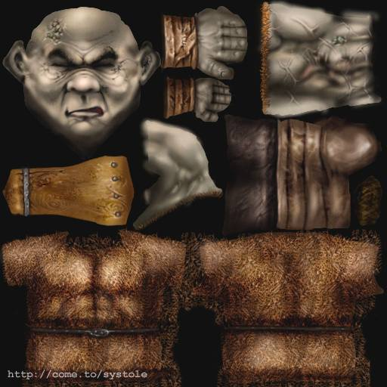

**Image 2 Texture Example**

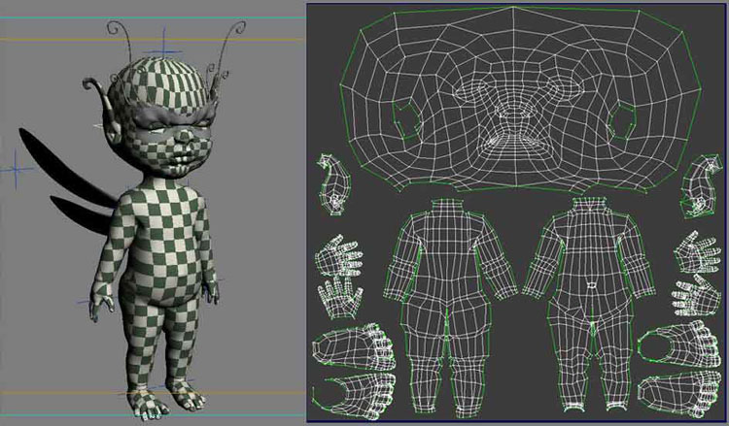

**Image 3 UV Wrapping Example [2]**

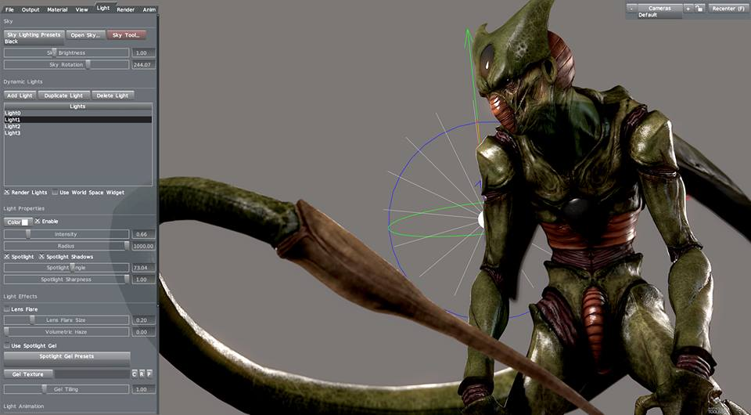

**Image 4 Finished Model Example**

* + - 1. **Character Rigging**

The parts of body which is needed to be rigged are **head**, **arms**, **hands**, **fingers**, **legs**, **body**, **tails** (**if any**), **wings** (**if any**), and **any other moveable part.**

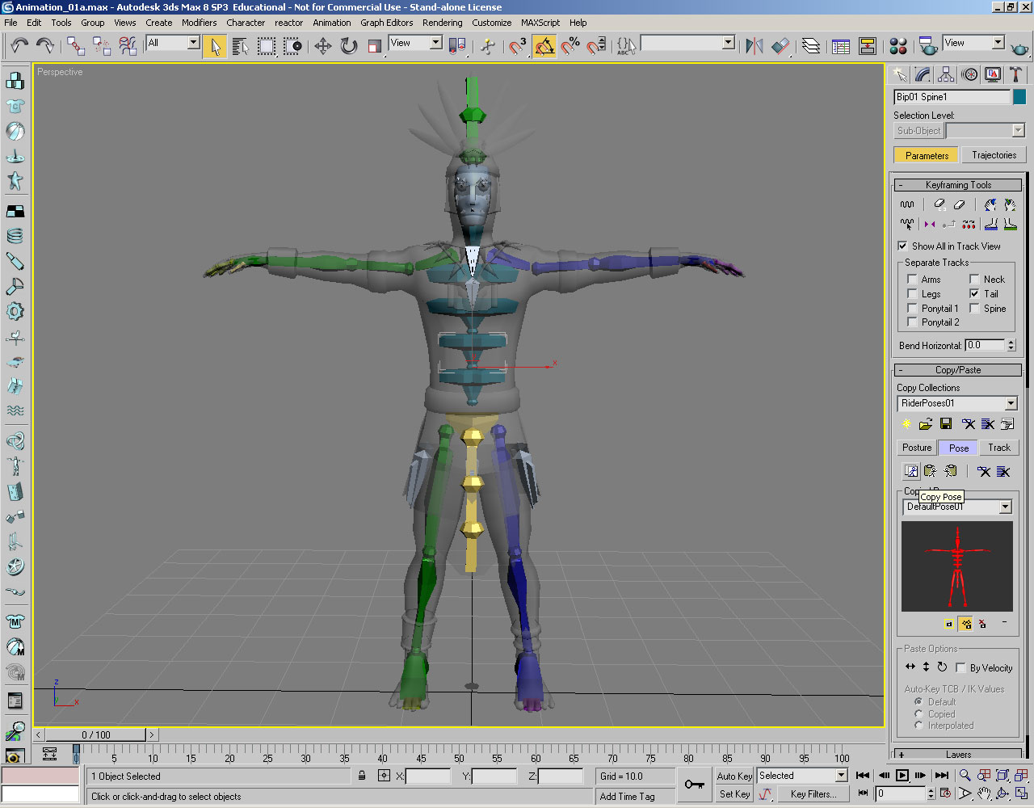

**Image 5 Character Rigging Example**

* + - 1. **Creating Scenery**

You can create your own scenery that matches your character’s appearance (e.g.: building, tree, and so on). Scenery that plain and simple (e.g., plain grassland, floor, and so on) will not to be marked. The scenery polygon is counted, don’t use an overly detailed or oversized scenery.

* + - 1. **Animating your character**

Your character needs to perform at least **five types of animation** (e.g.: punching, kicking, facial animation, and so on). The animation must describe the move of your character has based on the real one, or you can create yourself as long as the move match with the character.

One of the moves must be a **walking** or **running animation** performed by your character. Create your own a walking animation, don’t use the animation that provided by 3DS MAX.

* + - 1. **Creating a movie**

Create a short movie that featuring your character. The movie must have at least **15 seconds duration**. The following is the rule of your movie:

* + - Your character must perform all animation you’ve been created on your movie.
    - The scenery must be visible during the movie.
    - Modify the camera to obtain a better view of your character’s animation.
    - You must use camera switching to dynamically switch camera during the movie.
    - Use **lighting** (**directional** **light not counted** as lighting because it is **mandatory**) **and** **particle effect** to enhance the movie

**Note:**

* Used **at least 2 modifiers** (e.g.: bend, twist, and so on) **for your object** (i.e.: character/ accessories/ scenery). UVW Map/ Unwrap UVW/ the other modifier that used for texturing will not be counted as modifier because it is **mandatory**.
* For every 3ds Max file (*.max) that has been created, advised not to collapse your object.

**Files that must be collected**:

1. 3ds Max file (*.max)
2. Reference files in **“*Reference*”** folder, e.g.: blueprint file, and so on (*.png/ *.jpg).
3. Texture files in **“*Texture”*** folder, e.g.: texture images (*.png/ *.jpg), wrapping files (*.psd).
4. Movie file in **“Movie”** folder (*.mp4/ *.avi)
5. **Documentation** of modifier that you used, accessories and animation that you created, print screen and give an explanation about how you used the modifier effect.

Here are the rules that you must follow to create your project:

1. Use appropriate software for this subject based on **Sistem Praktikum** that can be downloaded from Binusmaya.
2. Collect appropriate files for this subject based on **Sistem Praktikum** that can be downloaded from Binusmaya.
3. Include the other files that can support your project, such as:
   1. All files in your project
   2. Other files (image, audio, video, etc.) used in your project
   3. *.DOC file (documentation of your project) that contains the reference links of additional files (image, audio, video, etc.) used in your project
4. If there are some hidden creativities, please note them in the existing documentation because they can greatly affect your project score

**Referensi**

*Reference*

1. <https://s-media-cache-ak0.pinimg.com/736x/ff/36/99/ff3699a7e3fe6a9d43e945f128885873.jpg>
2. <https://i.pinimg.com/564x/a2/0e/73/a20e73b90d4680dbdb326ff32513dfcc.jpg>

**If you do not understand, please ask your assistant!**